https://github.com/vg-2022/embedded

AIM - Program for 16 bit addition.

Code:-
LDI R16, $08 LDI R17, $02 LDI R18, $05 LDI R19, $01 LDI R21, $00 ADD R16, R18 BRSH L1
INC R21
L1: ADD R17, R19 ADD R17, R21

Output:-

Name
ø R16 R17

R14 R15 R16 R17 R18 R19 R20 RM

0x00
0x00
0x0D
0x03
0x05
0x01
0x00
0x00
Vaue
13

Al3¥-Programfor16 bit Subtraction.

Code:-
LDI R16,$08 LDI R17,$02 LDI R18,$05 LDI R19,$01 LDI R21,$00 SUB R16, R18 BRSH L1
INC R21
L1: SUB R17,R19 ADD R17,R21

Output:-

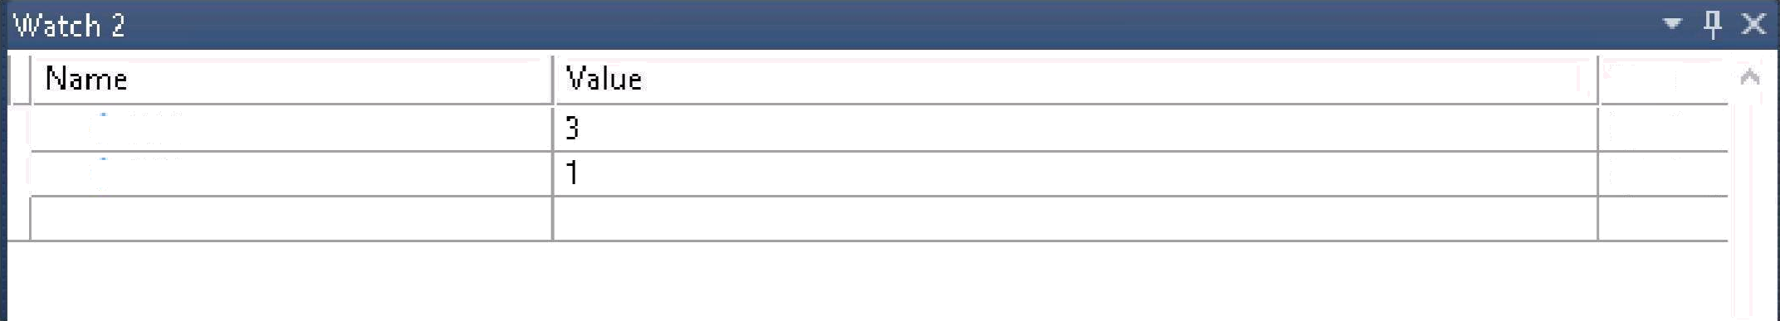
> R16
> R17
Type
byte(reg byte(reg

R14 R15 R16 R17 R18 R19 R20
0x00
0x00
0x03
0x01
0x0S
0x01
0x00

Practical No. 3
Aim- Program for Multi Byte Addition.

Code:-
LDI R16,$12 LDI R17,$04 LDI R18, $0A LDI R19, $08 LDI R20,$07 LDI R21, $00 ADD R16, R17 BRSH L1
INC R21
L1: ADD R16,R18 BRSH L2
INC R21
L2: ADD R16,R19 BRSH L3
INC R21
L3:ADD R16,R20 BRSH L4
INC R21
L4:/// end

Output:-

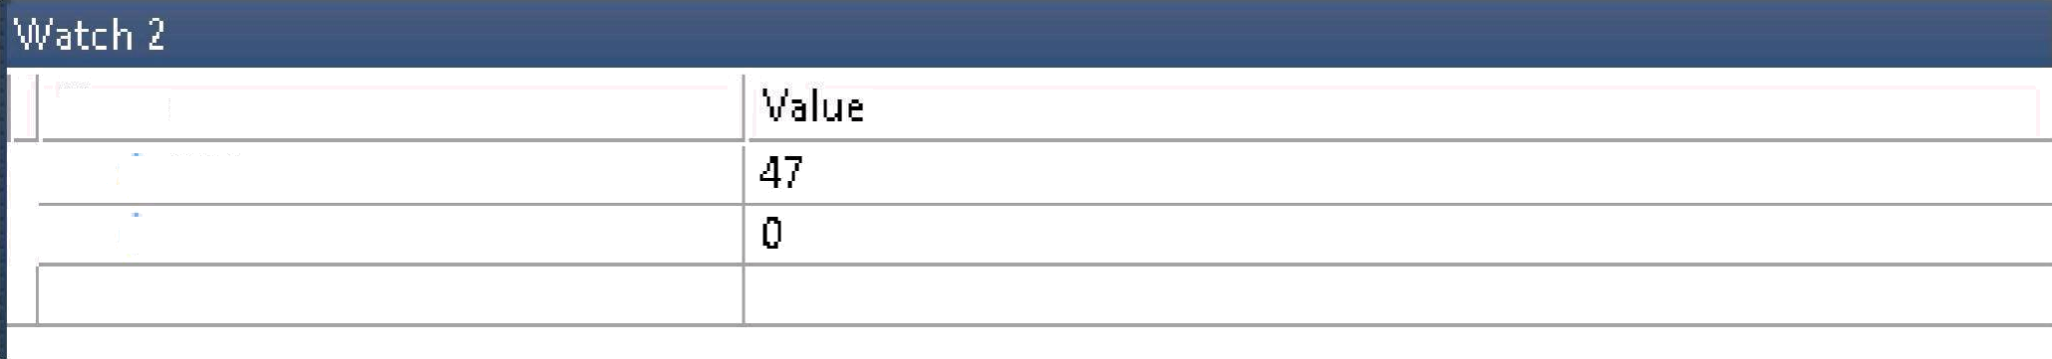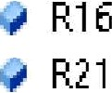
Name


RU R16 R17 R18 R19
Rź0
RU

0x08

Practical No. 4
AIM- Program for Multi Byte Subtraction.

Code:-
LDI R16, $12 LDI R17, $04 LDI R18, $0A LDI R19, $08
LDI R20,$07 LDI R21,$00 sub R16,R17 BRSH L1
INC R21
L1: sub R16,R18 BRSH L2
INC R21
L2: sub R16,R19 BRSH L3
INC R21 L3:sub R16,R20 BRSH L4
INC R21
L4:/// end

Output:-
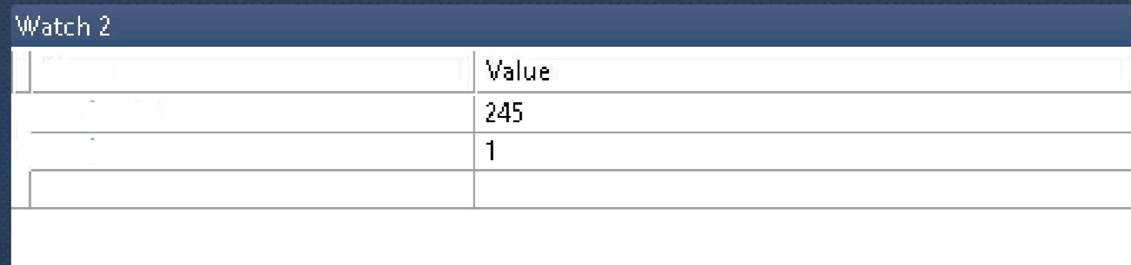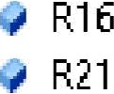
Name

Name | Value
Program Counter | 0x00000000
Stack p ointer | 0x00000000
X Register | 0x0000
Y Register | 0x0000
Z Register | 0x0000
Status Register | @
Cycle Counter | 16384
Frequency | 1.000 MHz
Stop Watch | 16,384.00 gs
+‘ Registers

R16 R17 R18 R19 R20 RU R22

0xF5
0x04

0x08
0x07 D:01
0x0d

Practical No. 5

Aim- ProgramforMultiplytwo8-bitnumbers and store the16 bit result in memory.

Code:-
LDI R16,$04 LDI R17,$05 MOV R20,R16 DEC R17
L1:ADD R16,R20 DEC R17
BRNE L1
STS 0x300,R17

Output:-

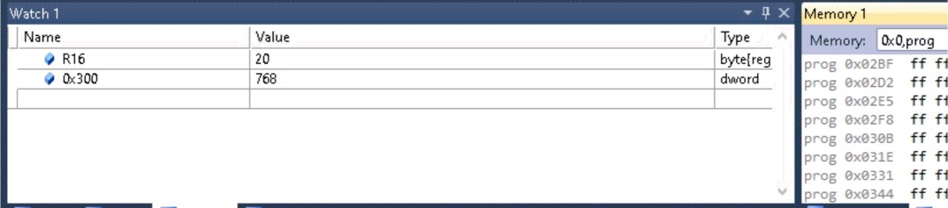

AU- ProgramforDividea16 bit number by 8 bit numberandstorethequotient and remainder in twoconsecutivememoryloction.

Code:-
LDI R16,0x0a LDI R17,0x00 LDI R18,0x04 LDI R19,0x00 LDI R20,0x00 U:ADD Rl7,R18 MOV R20,R16 SUB R20,R17
BRMI result INC R19 BRNE L1
STS 0x300,R22
BREQ over RESULT:SUB R17,R18 MOV R21,R17
SUB R16,R21 MOV R20, R16 STS 0x300,R19 STS 0x30l,R20 OVER :

Ft2O

Ox0O OxOP
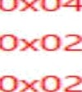

OxOO OxOO

Practical 7

AI%:- Program to transfer a block of data.

Cedei-
LDI R16,5 LDI
xL,ex3e LDz
xH,exei LDI
yL,ex6e Loz yH,exee L1: LD R2e,x+ ST v+,R2e DEc R16 BRNE L1

Output: -
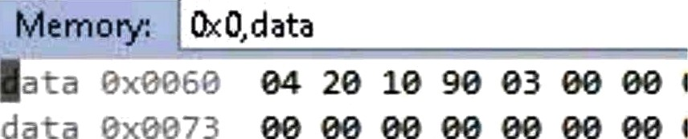
Memory: 0x0,data Addr‹

Practical No. 8

AIR:- Program to find the number of zeros in the 8 bit data.

Cedet-
LDS R 7,eXeeee LDI R1 ,e LDI R2e,eXe8 LDI R19,8 L1:ROR R17 BRSH L2 INC R18 L2:DEC R19 BRNE L1 SUB R2e,R 8 MOV R18,R2e
LTD eXeee1,R18

Output: -

Memory: 0x0,data
12 :?iS 00 I

Pzact1cal Ro. 9
AIM:- Pzogzam that f1nds the pos1t1on of the first high in an 8-bit data. The data is scanned from D7 to D0.

Cedet-
CLC
LDI R16, e
LDI R24, 23 LDI R17, 8 INC R16 LOOP: ROL R24
BRCC ENDLOOP
INC R16
ENDLOOP: DEC
R17
BRNE LOOP

Output: -
, , oi „.
v v  w | r24 R16  R16 | 11
 | R20 | 0
d | r17 | 0
v | r | Unknown identifier

Practical No. 10
AIM:- @zogzam to seazcha g1ven
number in a given list of 10 numbers.

Cedet-
LDI R17, 1e
LDz xL,ex3e LDz xH,exee LDI R16, 3 L1: LD R18, X CP R18,R16
BREQ L2
INC XL
DEC R17 BRNE
L1
L2: nOv R2e,xL
NOV R21, XH

Output: -
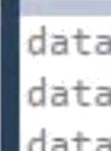
23 11 2S 83 78 83 56 10 34 77 00 0
00 00 00 GB 00 00 00 00 00 00 GB 0
Program Counter 0x00000000 Stack Pointer 0x00000000
X Register C.:•: 0c*?!°
Y Register 0x0000

R19 R20 R21 R22
0x00

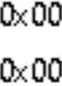

PzactżcaI Ro. 11
Azm Program to generate first ten terms of Fibonacci series.

Cedet-
LDI R24,8 LDI R17,1 LDI XL,eXee LDI

xH,exee LDz
Ri6,exee sT
X+, R16 INC R16 ST X+, R16 ST X+,R16 L1: MOV R21,R16 ADD
R16,R17 ST X+,R16 MOV R17,R21 DEC R24 BRNE L1


Memory: 0x0,data Address: 0x0
00 01 01 02 03 05 08 0d 15 22 37 00 f
- 00 CB 22 00 CB fB 00 Ob 00 00 B0 CB E
. 00 00 00 00 00 20 00 08 00 00 &B 00 E

Practical No. 12
Aim write a program to monitor the
PB7 b1t. When It 1s kOW , send $55
and $AA to GPort continuously.

cbi DDRB,7 ldi R16,e f out
DDRC,R16 ldi
R17,$55 ldi
R18,$AA ldi R23,e 11: in R2e, zNB
sbrs R2e, 7
rjmp 12 dec R23 brne 11
12: out PORTC,R17 out PORTC,R18
dec R23 brne 11

Output: -
 | fe | ff | 08 | 00 | 0€
 | 55 | 00 | 00 | 3f | 0€
 | 00 | 00 | 00 | 08 | 0£

Name- Vipin Mishra
Roll no. - 6060
Sub. - Embedded system

Submitted to:
Dr. Jyoti gnond Mo'om

Pr octical 1

Aim - Flashing on Board LED(Uno) at an observable rate.
Apparatus Required — Arduino uno.
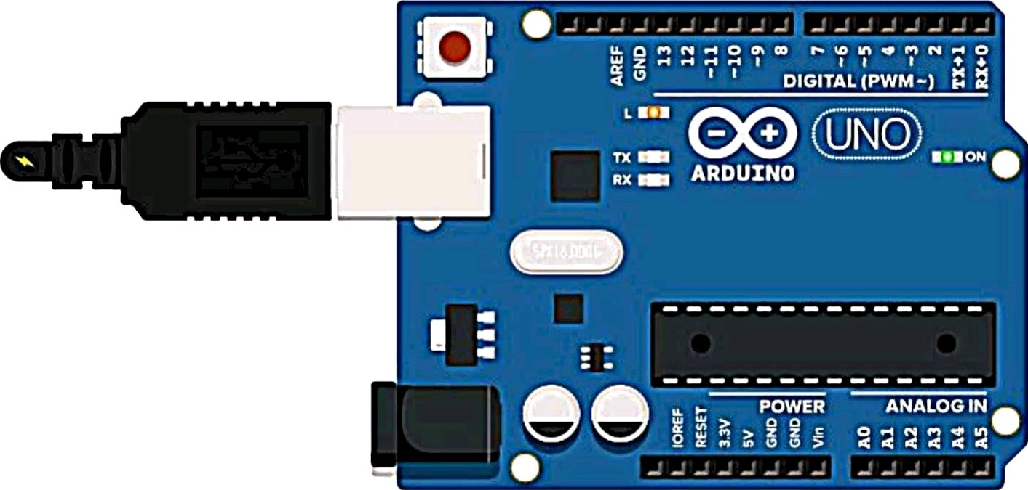
Code -
void setup()

pinMode(LED„BUILTIN, OUTPUT);

void loop()

digitalWrite(LED_BUILTIN,HIGH); delay(2000); digitaIWrite(LED_BUILTIN, LOW); delay(2000);

Practicol 2

AilTl' Hello LED-Flash LED at a rate such that the LED appears always on. Estimate the onset of the rate when the LED appears to stay on.


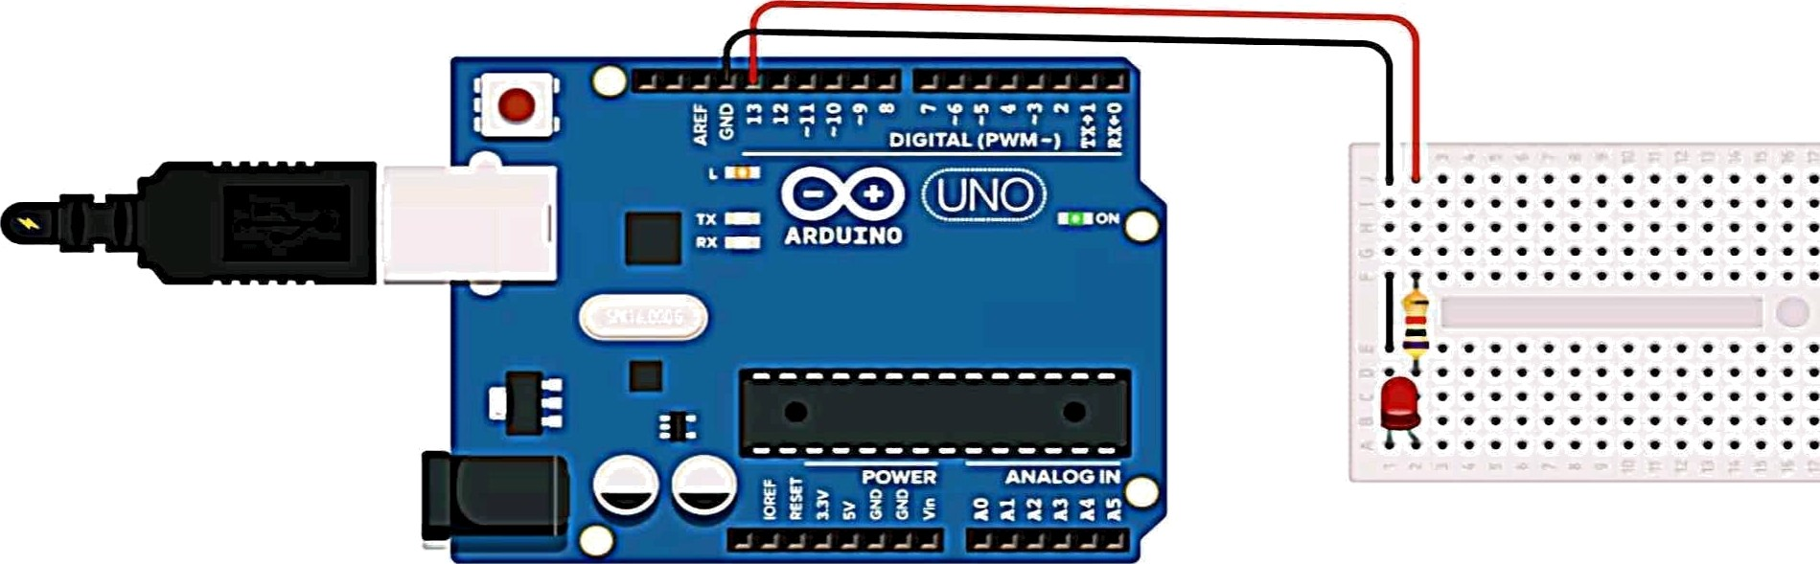

Code:
void setup()

pinMode(13,OUTPUT);

void loop()

int soundsens=analogRead(soundpin); if (soundsens>=threshold)

void loop()

digitalWrite(13,HIGH); deIay(10); digitalWrite(13,LOW); deIay(10);

else

digitalWrite(Iedpin,HIGH); //turns led on
Serial.println(soundsens);
deIay(100);

digitalWrite(Iedpin,LOW);



Aim - ON/OFF external LED with push button switch.
Apparatus Required — Arduino uno, LED, 220 ohm and 10k ohm resistor, push button, wires.

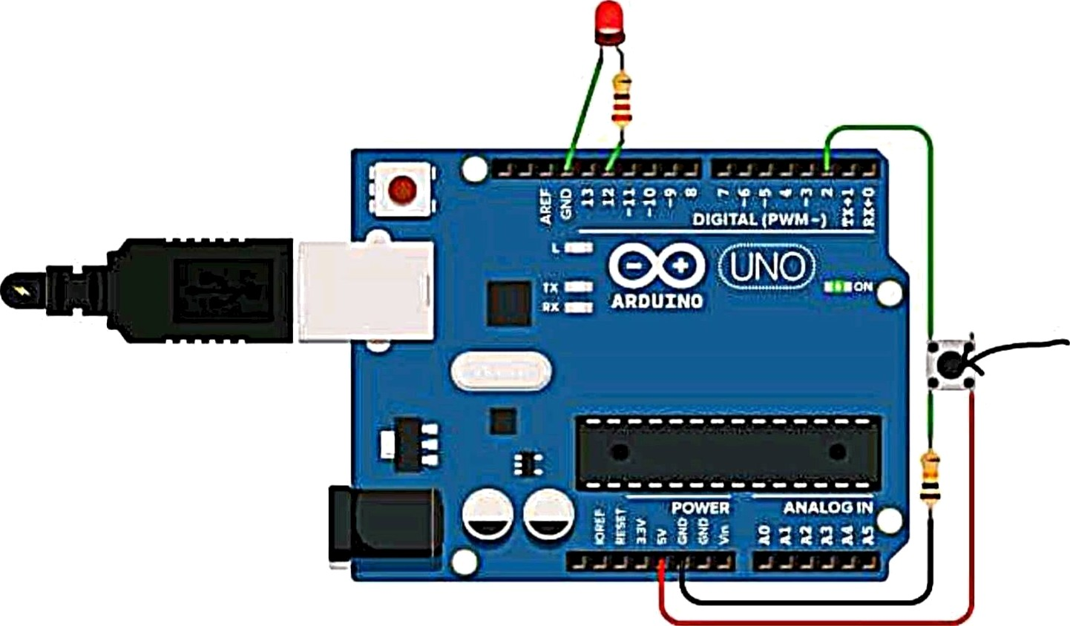
Code -
int buttonstate = 0; void setup()

pinMode(2, INPUT); pinMode(12, OUTPUT);

void loop()
When button is pushed

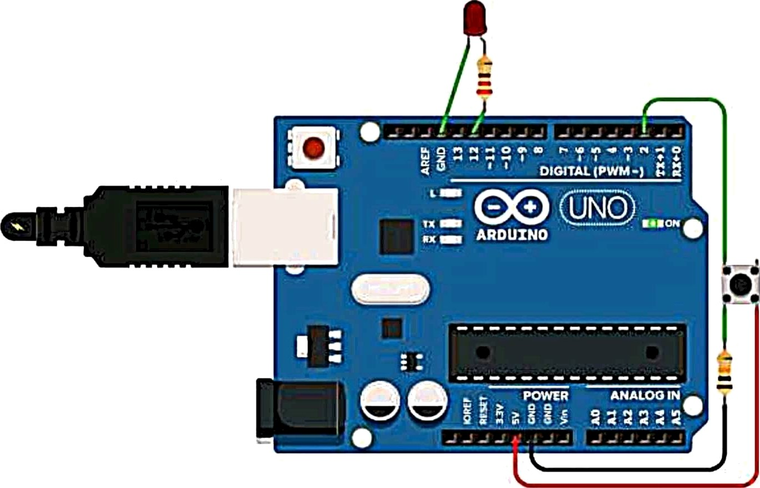
buttonstate = digitaIRead(2); if (buttonstate == HIGH) ( digitaIWrite(12, HIGH);
} else {

digitaIWrite(12, LOW);

delay(10);



Aim - Interfacing of DC Geared Motor.
Apparatus Required — Arduino uno, DC motor, push button, resistor, wires.

Code -
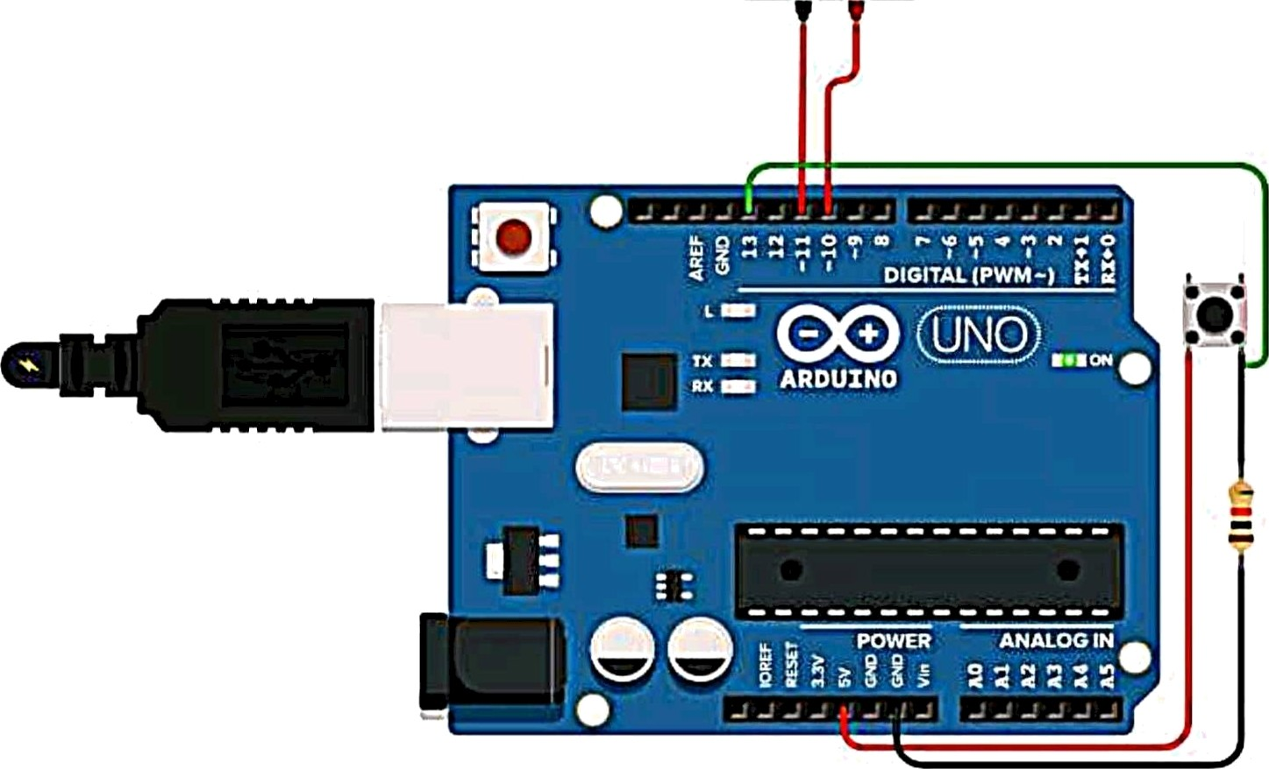
int button = 0; void setup()

pinMode(13, INPUT); pinMode(10, OUTPUT); pinMode(11, OUTPUT);

void loop()


button = digitaIRead(13); if(button == HIGH)

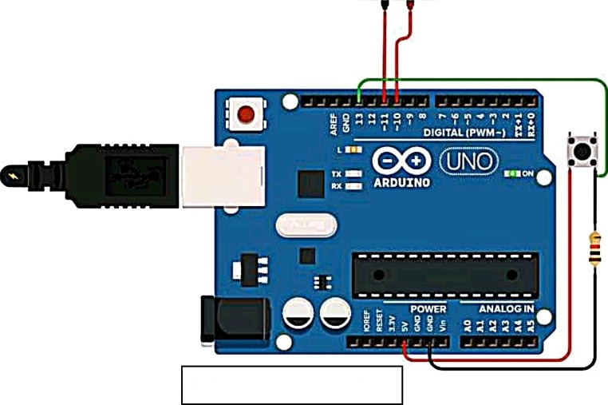analogWrite(11,2); analogWrite(10,0);
When button is pushed

else

analogWrite(11,0); analogWrite(10,2);

delay(20);



Aim - Interfacing of Stepper Motor.
Apparatus Required — Arduino uno, Stepper motor, wires.

Code —
#include <Stepper.h>

const int stepsPerRevolution = 200;

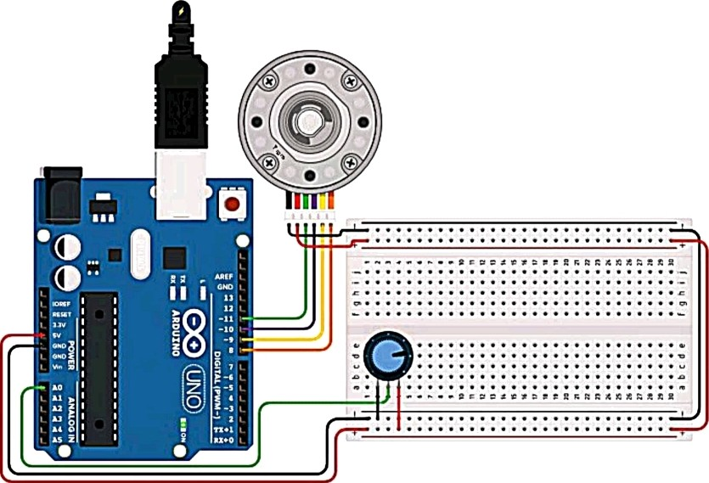
Stepper myStepper(stepsPerRevoIution, 8, 9, 10, 11);

void setup() {

void loop() (

int sensorReading = anaIogRead(AO);
int motorspeed = map(sensorReading, 0, 1023,
0, 100);
if (motorspeed > 0) { mystepper.setSpeed(motorspeed); mystepper.step(stepsPerRevolution / 100);



Aim: LED control using sound sensor.
Circuit

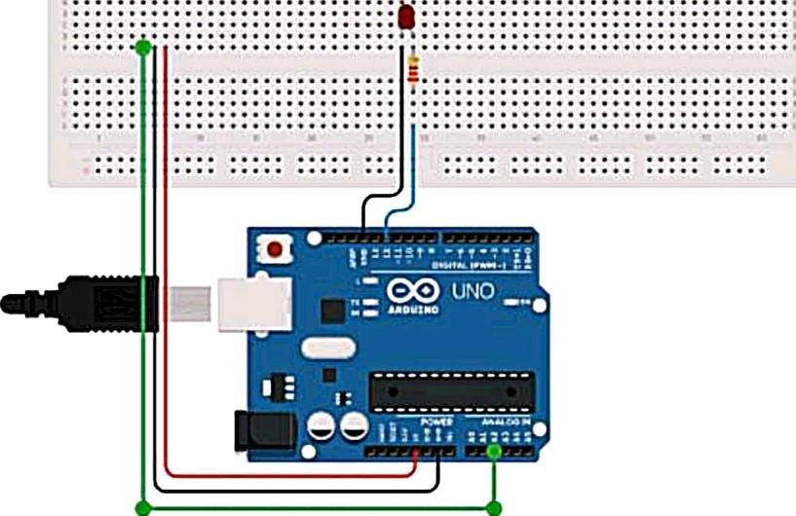

Code
const int ledpin=12; // led is connected to pin 12
const int soundpin=A2; // sound sensor AO pin is connected to pin A2
const int threshold=520; // sets threshold value for sound

sensor

void setup()

Serial.begin(9600); pinMode(ledpin,OUTPUT); pinMode(soundpin,INPUT);



Aim: Interfacing of LED matrix.

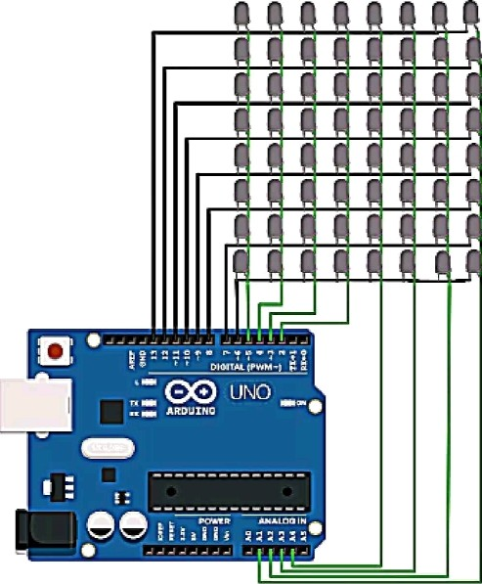
Circuit

Code

#define ROW1 13
#define ROW2 12
#define ROW3 11
#define ROW4 10
#define ROW5 9

#define ROW6 8
#define ROW7 7

#define ROW8 6

#define COL1 5
#define COL2 4
#define COL3 3

void setup() {
( 71,0,’£ £ 71,1t,
I .+.*. +.1))/

#define COL4 2 #define COL5 A4 #define COL6 A3 #define COL7 A2 #define COL8 A1

const int row[] = (ROW1, ROW2, ROW3, ROW4, ROW5, ROW6, ROW7, ROW8);
const int col[j = (COL1,COL2, COL3, COL4, COLS, COL6, COL7,
coL8);
Int stay(ay=tl1,z,1,1,1,1,1,1),
(1,1,1,0,0,1,1,1),
(1,1,0,1,1,0,1,1),
(1,1,0,1,1,0,1,1),

’¢ ’7 / 7 / / ’z' *

(1,1,0,1,1,0,1,1),
Serial.begin(9600);
for (int i = 2; i <= 13; i++) { pinMode(i, OUTPUT); digitalWrite(i, LOW);

pinMode(A1, OUTPUT); digitalWrite(A1, LOW); pinMode(A2, OUTPUT); digitaIWrite(A2, LOW); pinMode(A3, OUTPUT); digitaIWrite(A3, LOW); pinMode(A4, OUTPUT); digitalWrite(A4, LOW);

void loop() { delay(10); yaz(A);

void yaz(int matrix[8][8])( for (int c=O; c<8; c++){ digitalWrite(col[c], HIGH); for (int r = 0; r < 8; r++)(
digitalWrite(row[r], 255*matrix[r][c]); delay(1);

for (int r = 0; r < 8; r++){ digitalWrite(row[r], HIGH); delay(1);

digitalWrite(col[c], LOW);

